Nasdaq Index 2015-2017 Conclusion

# Data has been reduced to 2016-2017

# Index trend

Based on Index data and general trend line upwards trend is obvious.

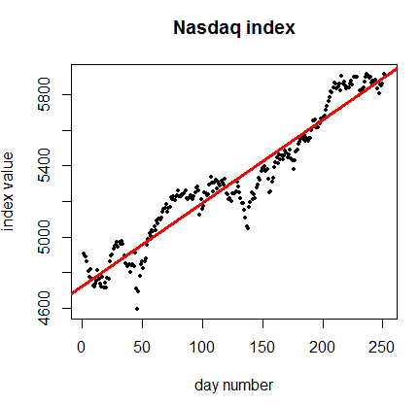

Model results:

Adjusted R-squared: **0.9226**

Coefficients:

Estimate Std. Error t value Pr(>|t|)

(Intercept) 4.724e+03 1.248e+01 378.62 <2e-16

x 4.678e+00 8.551e-02 54.71 <2e-16

that means that all **coefficients are significant**.

# Distribution

Based on Shapiro test, returns do not follow a normal distribution.

Shapiro-Wilk normality test results:

W = 0.94862, p-value = 9.861e-08

# Daily parameters:

* Mean = 0.0007697741
* Median = 0.001261646
* Standard Deviation = 0.007426436

# Comparison with others

Investing in Nasdaq index in 2016 it was possible to gain (annually):

(5910.52 - 4906.23) : 4906.23 = 20.47%

Annual volatility is equal to

0.007426436* sqrt(252) = 11.79 %

T-bills return

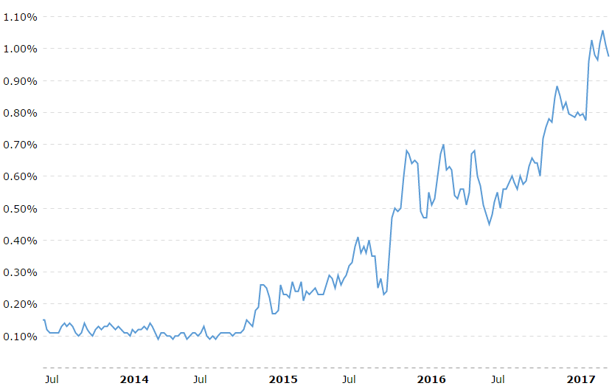

Figure 1 1 year T-bills return

The return was less than 1%. Compared with 20% from Nasdaq Index it is 20 times less.

Approximately the same result gives investing in S&P500:

Annualized return: 12.29%

Annualized volatility: 9.81%

Return / Volatility (risk) ratio:

Nasdaq: 20.47 / 11.79 = 1.74

S&P500: 12.29 / 9.81 = 1.25

# Conclusion

As a conclusion, investing in Nasdaq Index in 2016 was a good idea, comparing with S&P500, Nasdaq Index performed better (based on Return/Risk Ratio)